EN EL LOAD

1. Clear container
2. Get number of rows\
3. Cargue primeros 10 registros
4. Generate container accordint to number of rows < Pages 1 2 3 4 >
5. Each button calls to retrieve from web server according to offset
6. Clear container

document.getElementById(elementID).innerHTML = "";

1. Get number of rows y lo almacena en HiddenField
2. Cargue primeros 10 registros
3. Genere container

HTML Inicial debe haber un container para los “page numbers”

<p>

<div id="pages"></div>

</p>

For each Page include

<button class=’btn-link’ onClick=’Fx(1); return false; > button like a link</button>

var include = “”;

for (int i=1; i< NumRows; i++)

{

string pos = i.toString();

Include = include + “<button class=’btn-link’ onClick=’RecreateTable(“+pos+“); return false; > “+ pos + “</button>&nbsp; “;

}

var container = document.getElementById('pages');

container.innerHTML = "";

conteiner.insertAdjacentHTML('beforeend', Include);

It will change to…

<p>

<div id="pages"></div>

<a >1 </a> <a >2 </a>

</p>

En la function RecreateTable

Al inicio el container es

<table id='table1' class="gridtable"></table>

function Recreate_Table1(string pageNo) {

// clean table NO APARECE DENTRO DE CONTENER CUANDO DOY **VIEW CODE** !!!

var Table1 = document.getElementById("table1");

while (Table1.hasChildNodes()) {

Table1.removeChild(Table1.firstChild);

}

$('#table1').append('<tr><th>Frequency</th> <th>Start Time</th> <th>End Time</th> <th>Status</th></tr>');

$.ajax({

type: "POST",

url: "SearchRunLog.aspx/GetDataTable",

data: "{opcion: '" + pageNo + "'}",

contentType: "application/json; charset=utf-8",

dataType: "json",

async: true,

success: function (response) {

for (var i = 0; i < response.d.length; i++) {

var f1 = response.d[i].Frequency;

var f2 = response.d[i].StartTime;

var f3 = response.d[i].EndTime;

var f4 = response.d[i].Status1;

$('#table1').append('<tr><td>' + f1 + '</td> <td>' + f2 + '</td><td>' + f3 + '</td><td>' + f4 + '</td></tr>');

}

}

});

}

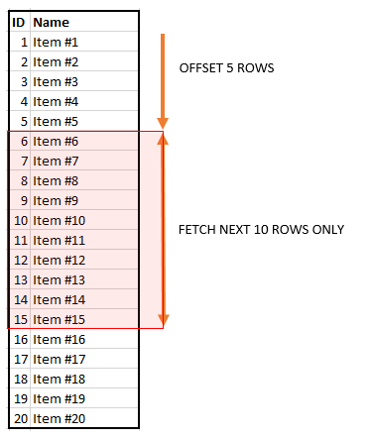

In the select

SELECT * FROM products

ORDER BY  list_price, product_name

OFFSET 5 ROWS

FETCH NEXT 10 ROWS ONLY;

SELECT * FROM products

ORDER BY  list_price, product_name

OFFSET @NumROws ROWS

FETCH NEXT 10 ROWS ONLY;

.button-link {

  background: none!important;

  border: none;

  padding: 0!important;

  /*optional*/

  font-family: arial, sans-serif;

  /*input has OS specific font-family*/

  color: #069;

  text-decoration: underline;

  cursor: pointer;

}

function pages() {

            var add1 = "";

            for (count = 1; count < 5; count++) {

                add1 = add1 + "<button class='button-link'

onclick='Recreate_Table("+count.toString()+");return false;'>"

+count.toString()+"</button>&nbsp;";

            }

            var div = document.getElementById('test');

            div.innerHTML = add1;

        }

<link rel="stylesheet" href="https://stackpath.bootstrapcdn.com/bootstrap/4.1.1/css/bootstrap.min.css" integrity="sha384-WskhaSGFgHYWDcbwN70/dfYBj47jz9qbsMId/iRN3ewGhXQFZCSftd1LZCfmhktB" crossorigin="anonymous">

<button type="button" class="btn btn-link">Link</button>